**Persuasive Advertisements Using All Three Appeals (Ethos, Pathos, Logos)**

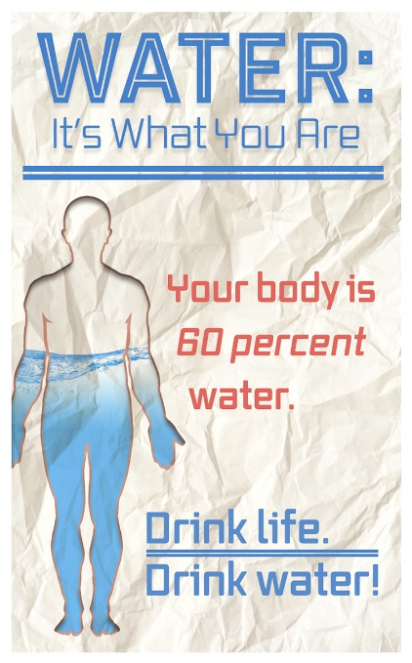

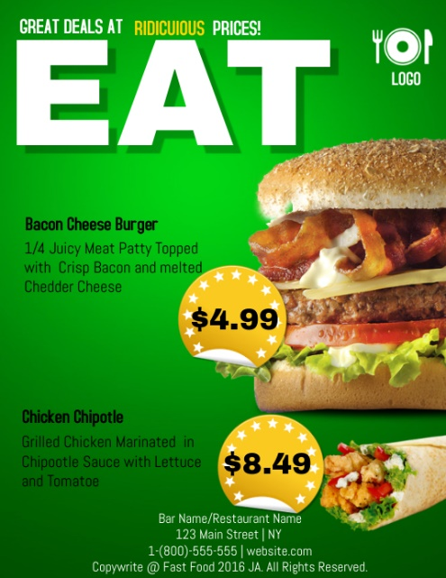





Appeals Advertisement

**Directions:** You will be to designing an advertisement that uses all three appeals; your ad should be made up and not one that already exists. **This will be worth 25 points – 5 pts. for each appeal used in your ad and 10 pts. for coloring and decorating the ad itself.**

